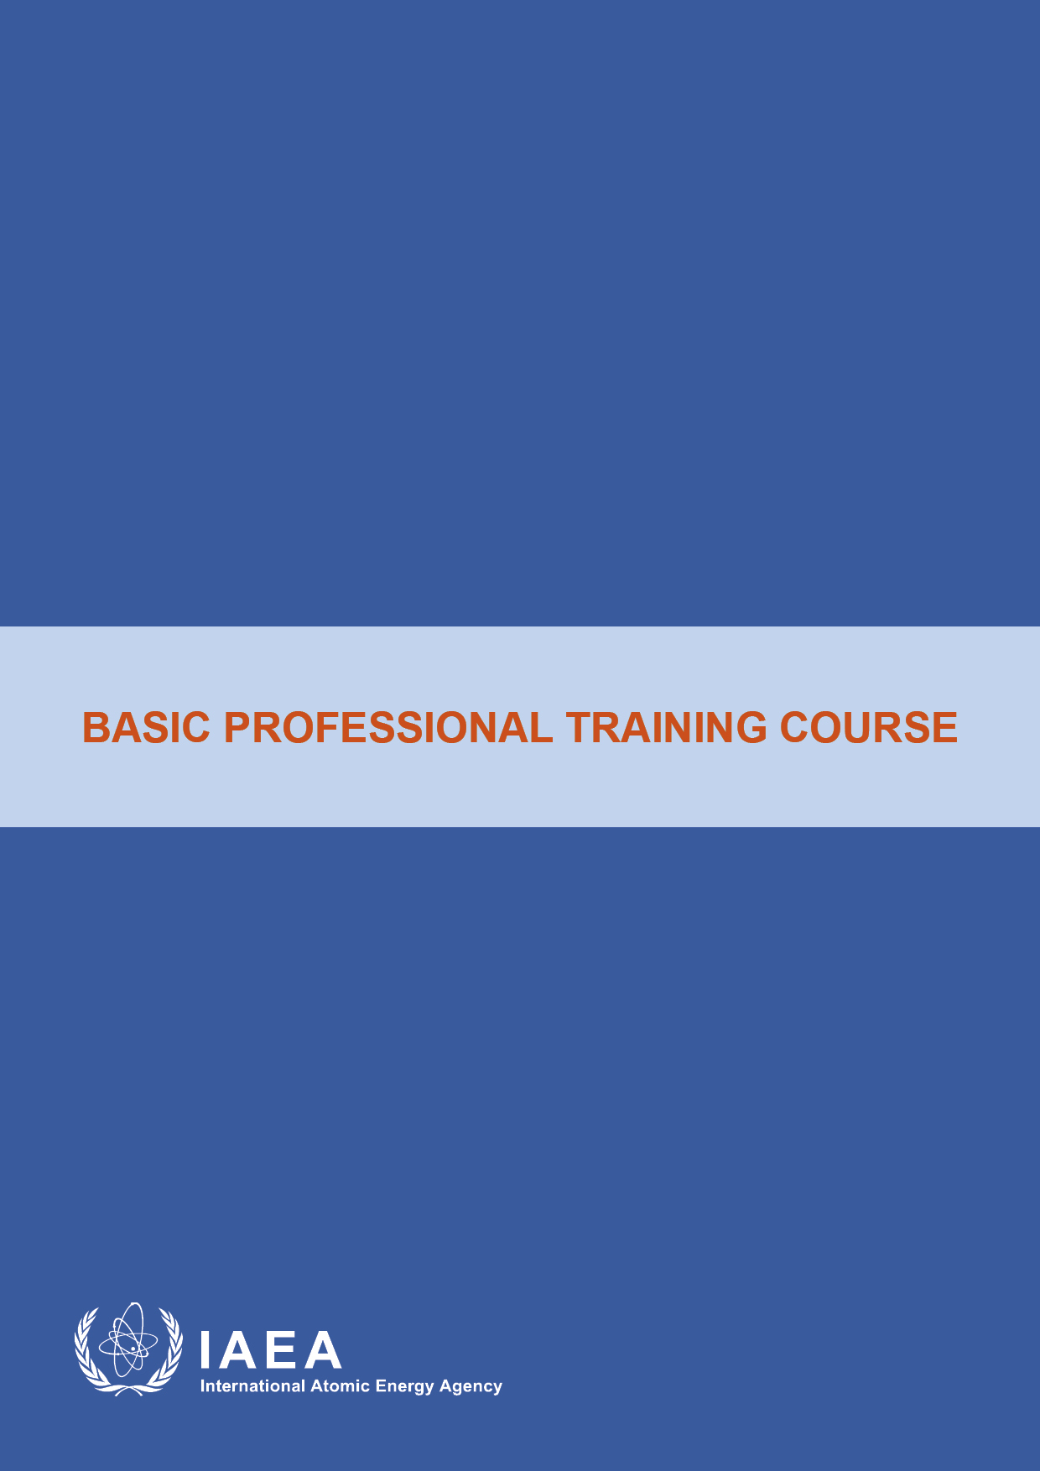

ModuleXX1

Leadership, Management for Safety and Safety Culture
Lecturer Guidance and Instructions

- General Guidance/Instructions Lecturer:

The training material is developed in 3 units of presentations (P1-P3) and 1 unit of exercise (case study 1) 90 minutes each, for delivery as follows:
1. Presentation on Integrated Management Systems
2. Presentation on Leadership for Safety
3. Presentation on Safety Culture
4. Case Study 1 on Leadership and Management
- Introductory remarks of the Lecturer should be given only on the first day of the workshop on name, qualification and experience of the lecturer on the topic.
- Learning Objective of the presentation should be mentioned for all the presentations
- Questions at the end of each presentation should be put forward for a 10-15 minutes discussion at the end of each presentation. The answers to these questions are provided in the attached document on Review Questions.

- Overall instructions to carry out the exercises
- Participants are required to form 3 groups
- Each group is requested to identify a group facilitator as well as a rapporteur.
- 90 minutes time is specified for the exercise.
- Groups are required to work as team and to complete the tasks.
- Groups have to prepare a 10 minute power point presentation of key findings that will be presented by the group rapporteur.
- Lecturers will be available to answer any query during exercise.

- Specific Instructions
IAEA Safety Standard Series No GSR Part 2 on Leadership and Management for Safety was taken as basis for preparation of this training material. Detail description of the contents of the slides is provided in slide notes.

P1. Integrated Management System
Slide 10 describes the evolution of management system from quality control to systemic approach to safety and slides 20-26 describe requirement of GSR Part 2 on Leadership and Management for Safety which supersedes IAEA Safety Standards Series GS-R-3 on the Management System for Facilities and Activities
Detail description is provided in the notes in the power point presentations.
Slide 13 describes the systemic approach to overall safety management taking into account leadership, safety culture and effective management for safety taking into consideration the ITO concept.

P2. Leadership for Safety
Slide 10 describes the GSR Part 2 Requirement 2 regarding demonstration of leadership for safety by managers and concept of leadership for safety and its roles and responsibilities for managing safety and providing a vision for managing growth of and change in the organization.

P3. Safety Culture
GSR Part 2 Requirement 2 and 12 provide requirements on Safety Culture and Requirement 14 on Assessment of Safety Culture provide basis for understanding concept of safety culture. Slide 18 has been added highlighting difference between safety culture and culture for safety. It provides concept that organizations have safety culture as one variable, while, culturc is inherent in all aspects of the organization to fulfill safety requirements.

Case Study 1

Leadership and Management for Safety

{1 unit of exercise 90 minutes in total}

All Participants to be split up into 3 Groups, to work on the case study and discuss the tasks and present their result in the form of presentations

Part I: Inbox

Objective
The objective of this exercise is to increase the participants’ understanding of the concept of leadership and management for safety and its practical application in day-to-day situations in an organization.

Key points to be addressed
Participants should be able to distinguish activities that relate to leadership from those that relate to management and the impact it has on follow-up action.

Input for the exercise
- Lilliput case study LNSA
- GSR Part 2 on Leadership and Management for safety

Tasks to be completed in the exercise
The following tasks should be completed in 90 minutes.
Task1
You are part of the management of LNSA (regulatory body) and you have just walked into the office and found the following tasks in your inbox. What do you do with this list?
- The minister has called an important meeting on the schedule for the new power plant - the utility wants to accelerate the plan for building the new NPP and it is expected that the minister will support this plan and ask the regulatory body to be in a position to deal with the accelerated plan.
- Meeting with foreign delegation from a country that wants to build partnership with the LNSA
- Expert meeting to review draft of new regulations on radiation protection
- There is note left indicating that your assistant has called in sick
- Presentation at university conference on the role of the LNSA
- There is a memo from the HR department requesting that a workforce plan for the regulatory body be developed by the end of next month
- An internal memo from the Administration Department is requesting a revision to budget projections in light of current demands and the ramp up in interactions with the utility
- The Review and Assessment Department has developed drafts of safety assessment standards that need to be reviewed and approved
- There is a letter from a supplier requesting clarification on the scope of future LNSA inspections with respect to suppliers
- There is a lunch on the agenda with a representative of an anti-nuclear NGO
- There is a memo from the Communications Department regarding a request for an interview by a journalist from the local newspaper
- The Public and International Affairs Department has submitted a draft of the first major activity report that needs to be produced this year by the LNSA
- The Administrative Department has reported the failure of the air condition in Building B
- The Licensing Department is requesting money to hire a consultant to help them develop a licensing process (the department has identified three potential candidates)
- The Inspection and Enforcement Department is requesting that a job or position description form be developed for the position of the head of the department
- There is a letter from the governor of one of the proposed sites of the NPP requesting the results of the Environmental Impact Analysis (EIA) for the site
- There is note from the minister requesting a strategic plan for the next five years
- The Administrative Department has sent a note warning that travel costs for meetings and conferences abroad (e.g. to the IAEA) have exceeded budgeted levels
- The Regulations and Guides Department is requesting the formation of an external advisory group to help it develop regulatory documents
- A retirement party needs to be organized for the most senior expert in the Licensing Department
- There is a memo from the Administration Department complaining about the candidate that the Licensing Department is insisting on hiring (the candidate is inexperienced but he or she is related to one of the managers in the department)
Task2
- Individually determine which items in the list are leadership tasks and which ones are management tasks?
- Which of these tasks may have an impact on safety?
- Which of these tasks are related to the Regulatory Body, Goals, Strategies, Objectives and Plans?
Task 3
Discuss the results of the individual assessment of these tasks and come to a consensus as a group on which tasks are leadership tasks and which ones are management tasks. Prepare a presentation of your consensus results.

Points for further discussion
Care should be exercised in the analysis of the tasks, as some may be both leadership and management task depending on the situation.
Consider the reasons why some tasks are both leadership and management tasks.

Annex-I
Additional instruction for workshop facilitators
The workshop facilitators should select, tailor and use the exercises according to: the participants and their actual needs, the member state(s) specific situation(s), and the specific actions associated with each phase.

Annex-II
Part I - ‘Inbox’:an aide to the exercise facilitator.
Expected Possible Results
Leadership |  | Management
A relationship: aligning people, selecting talent motivating, inspiring, coaching, building trust, creating shared understanding | 6 (before the finalisation of the workforce plan)  9 (as its only a 2-year old inexperienced regulatory body)  16 (in terms of creating a systematic approach to handling issues of this nature)  19  20 | A function : planning, task distribution, follow-up, budgeting, evaluations, problem solving, facilitating | 2  4  5 (create the presentation)  7
Leaders tend to |  | Managers tend to
Stress relationships with others, values and commitment (the emotional and spiritual aspects of the organization) | 21 | Stress organization, coordination and control of resources | 6 (for producing the draft)  18  20
Create and articulate a vision of what the organization could achieve in the long run | 5 (to deliver the presentation)  11  17 | Focus on the achievement of short-term objectives and goals | 3  13  16 (for resolving the immediate issue of directing the request to the right entity)
Move the organization in new directions, being unsatisfied with maintaining the status quo | 1  15  17 | Concentrate on maximizing results from existing functions and systems | 5 (to create the presentation)
Empower people to act on their own to achieve objectives | 10 (this could be delegated to the Head of the Public and International Affairs Department) | Insist that people check with them on every detail before they act
Generate a feeling of meaning in work, its value and importance | 12 | Enforce fulfilment of agreements and contracts for work | 18
Have an insatiable passion to continuously develop themselves, eager to learn |  | Not to push themselves to learn new things
Leaders take us to a better place |  | Managers provide and control | 8  14
leaders are not necessarily managers |  | Managers may be leaders

